Speed Numbers

A speed number is a pre-defined configuration that is saved and can be recalled. For example, the “Hilton Hotel” chain could order the same size Pedimat with a logo and other typical details, which could be the same for each hotel they build. A speed number would be an easy way to pull up this same configuration every time.

Speed numbers in eRapid are unique identifiers for a specific configuration of a model, usually configured with the most commonly used options. Upon loading a speed number, any selections can be modified or the entire speed number configuration can be erased by clicking the ‘Reset’ button.

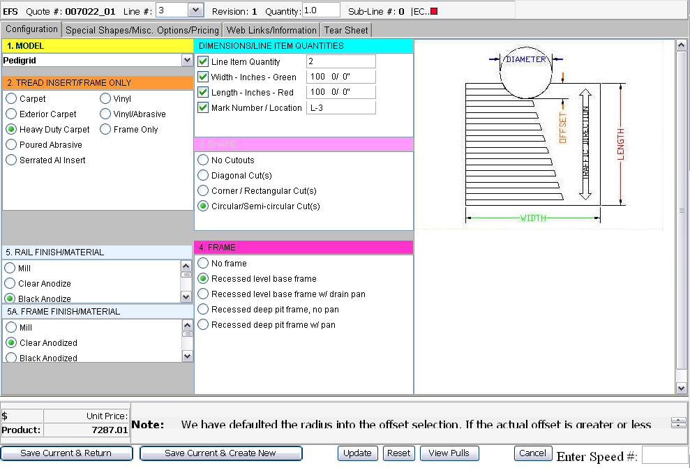

To load a speed number configuration, type the code in the box located at the bottom right of the screen, labeled “Enter Speed #:”, then press the Enter key.

Speed number codes match model numbers of the configured product. If a code is used and no configuration loads up, it means that the desired speed number doesn’t exist and it can be created by contacting the eRapid team.

Please note that speed numbers can be created only by the eRapid team or the Entrance Flooring Group representatives. Once created, they are available to all users.

End Section

